Guía2. Desarrollo Proyecto APT
Asignatura Capstone

1. APT Project Progress Summary
Below, you will find several fields to complete with the requested information.

APT Project Progress Summary | Web Interface Development: Progress was made in structuring the system’s main views in Streamlit, ensuring modular navigation and the initial integration of visual components.  Relational Database Implementation: A centralized PostgreSQL database was successfully designed, structured, and connected, enabling the persistent and secure management of the business’s operational data through normalized tables (Client, Supplier, Project, Budget, Purchase Invoice, and Sales Invoice).  Initiation of Artificial Intelligence Module Testing: The experimentation and technical testing phase for the time-series prediction and analysis engine began in an isolated development branch.
Objectives | Optional, if adjustments are made
Methodology | SCRUM
Progress Evidence | Creation of the user interface views  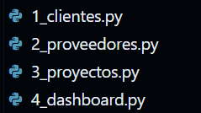  Functional and non-functional requirements spreadsheet  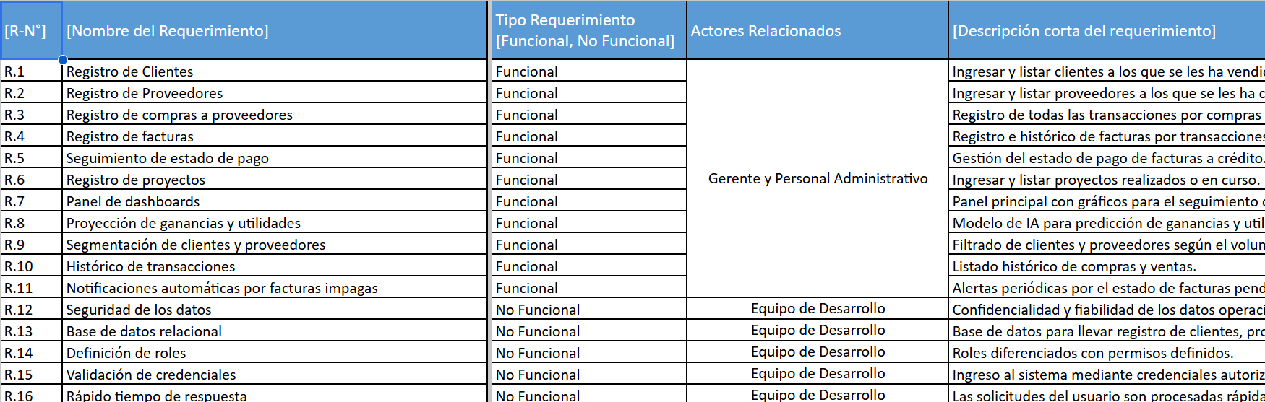  Design of the relational database model  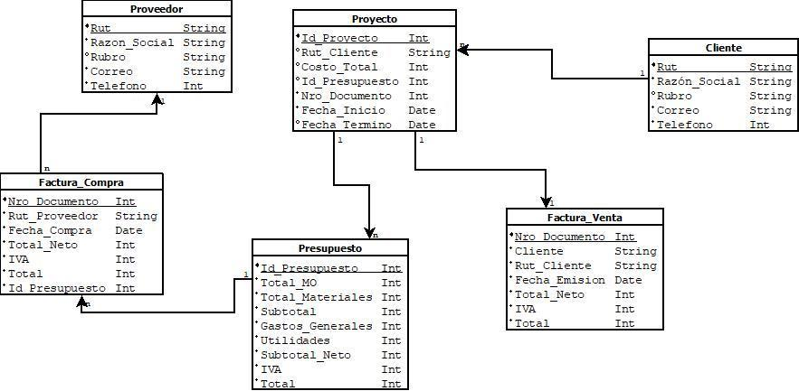
Progress Evidence | 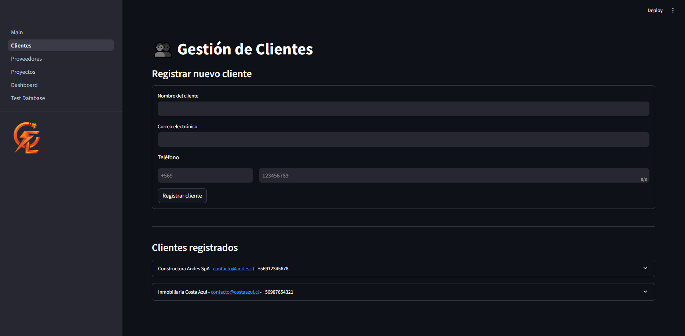
Progress Evidence | 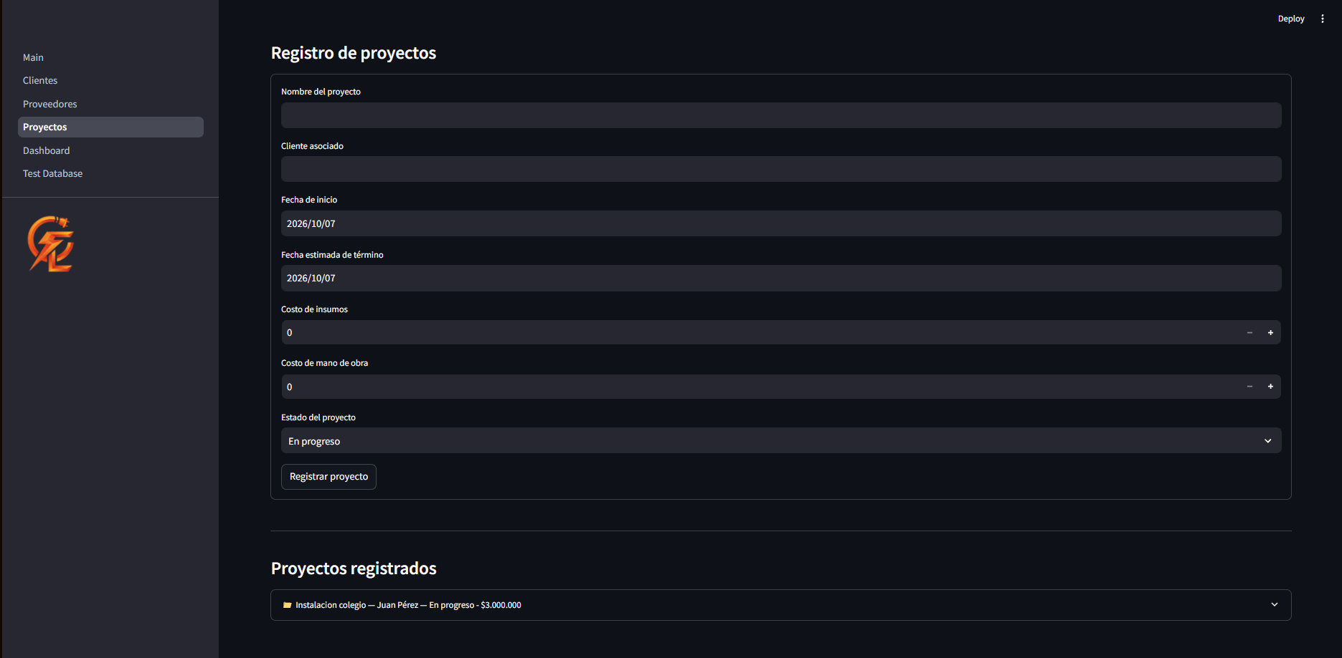
Progress Evidence | 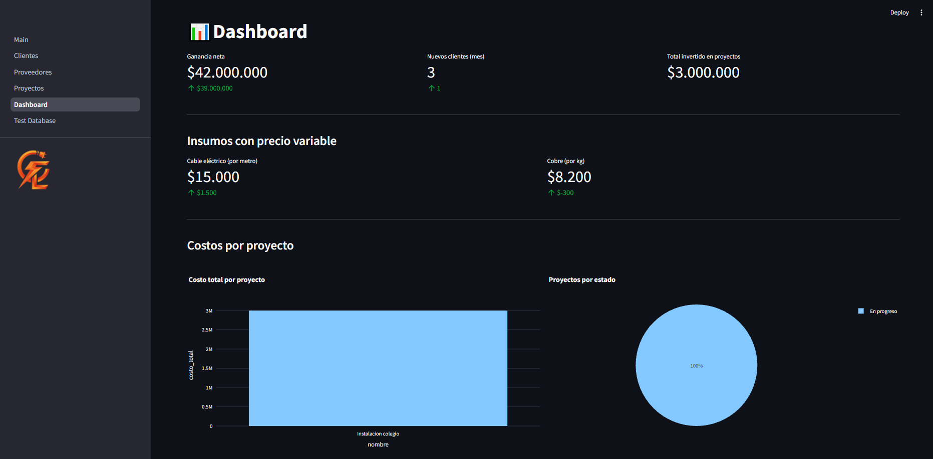
2. Work Plan Monitoring
Carefully review your work plan, focusing especially on the progress status and adjustments columns.

Work Plan
Competency or competency units | Activities | Resources | Activity duration | Person responsible | Notes | Progress status | Adjustments
Development of comprehensive and innovative solutions. | Front-end development.  Programming of the logic and database connection.  Database modeling and development | Computers with an internet connection  Open-source digital tools. | Between 2 and 3 weeks. Sprints of variable duration. | Tomás Vega  Natanael Yañez  Moisés Roa | Enablers:  Free, easy-to-use tools.  Challenges:  Integration of multiple tools. | Front end: In progress  Back end: In progress  Database connection: In progress  Database development: Completed

3. Adjustments Based on Monitoring

Factors that have facilitated and/or hindered the progress of my work plan: Describe the factors that have facilitated and/or hindered your APT Project so far. For any challenges, describe the actions you have taken and/or will take to address them.
Enabling factors: Having a dedicated space for testing. Working in branches has given us the freedom to experiment with code, try different libraries, and run unit tests with simulated data without interfering with or undoing the work of other team members.
Challenge: Initially, the selected framework (Scikit-Learn) was too basic, and we realized it would not perform well with highly variable data (invoice amounts) over time because its approach was too linear.

Adjusted or Removed Activities:
Adjusted activity: Migration of the baseline prediction model from Scikit-Learn (Linear Regression) to Prophet (Meta) for the time-series analysis and forecasting module.
Justification:
- Limitation of the initial model: Scikit-Learn treats time as a purely linear variable, which prevents it from accurately capturing the seasonal fluctuations typical of the business (such as weekly and monthly cycles or peaks around key dates).
Indicate the adjustments you made to your work plan or the activities you removed, and explain why. If your work plan has not required and does not require adjustments, justify this decision based on the enabling factors that have allowed you to carry it out as planned.

Activities Not Started or Delayed: If you have not started activities or they are behind schedule, explain why you have been unable to meet the planned deadlines and what strategies you will use to move these activities forward without negatively affecting your APT Project.

En caso de que el Proyecto APT sea grupal, en esta columna deben indicar el nombre de los responsables de cada tarea o actividad. Esto posteriormente permitirá diferenciar la evaluación por cada integrante.

